**Machine Learning Lab Manual**

**Dept. of CSE-IoT**

**Introduction to pandas**

* In developing, data science, and moving from excel-based analysis to the world of [Python](https://www.python.org/), scripting, and automated analysis, the incredibly popular data management library, “[Pandas](https://pandas.pydata.org/)” in Python.
* Pandas’ development started in 2008 with main developer [Wes McKinney](https://twitter.com/wesmckinn?lang=en) and the library has become a standard for data analysis and management using Python. Pandas fluency is essential for any Python-based data professional.

**What is a Python Pandas Data Frame?**

* A Data Frame is a “two-dimensional, size-mutable, potentially heterogeneous tabular data structure with labeled axes (rows and columns)”.
* In plain terms, think of a Data Frame as a table of data, i.e. a single set of formatted two-dimensional data, with the following characteristics:
* There can be multiple rows and columns in the data.
* Each row represents a sample of data,
* Each column contains a different variable that describes the samples (rows).
* The data in every column is usually the same type of data – e.g. numbers, strings, dates.
* Usually, unlike an excel data set, Data Frames avoid having missing values, and there are no gaps and empty values between rows or columns.

By way of example, the following data sets that would fit well in a Pandas Data Frame:

* **In a school system Data Frame** – each row could represent a single student in the school, and columns may represent the students name (string), age (number), date of birth (date), and address (string).
* **In an economics Data Frame,** each row may represent a single city or geographical area, and columns might include the the name of area (string), the population (number), the average age of the population (number), the number of households (number), the number of schools in each area (number) etc.
* **In a shop or e-commerce system Data Frame**, each row in a Data Frame may be used to represent a customer, where there are columns for the number of items purchased (number), the date of original registration (date), and the credit card number (string).

**Week 1**

Basic data handling commands:

1. Read data from the csv file

2. Dimension of the data

3. Display data (top 5 rows and total data)

4. List the column names of a data frame

5. Change columns of a data frame

6. Display specific single column or multiple columns of a data frame

7. Bind sets of rows of data frames

8. Bind sets of columns of data frames.

9. Find missing values in the dataset

**1.Read the data from CSV file**

* Creating Data Frames from CSV (comma-separated value) files is made extremely simple with the [read\_csv](https://pandas.pydata.org/pandas-docs/stable/generated/pandas.read_csv.html)() function in Pandas, once you know the path to your file.
* A CSV file is a text file containing data in table form, where columns are separated using the ‘,’ comma character, and rows are on separate lines.
* Dataset used is breast cancer prediction dataset.

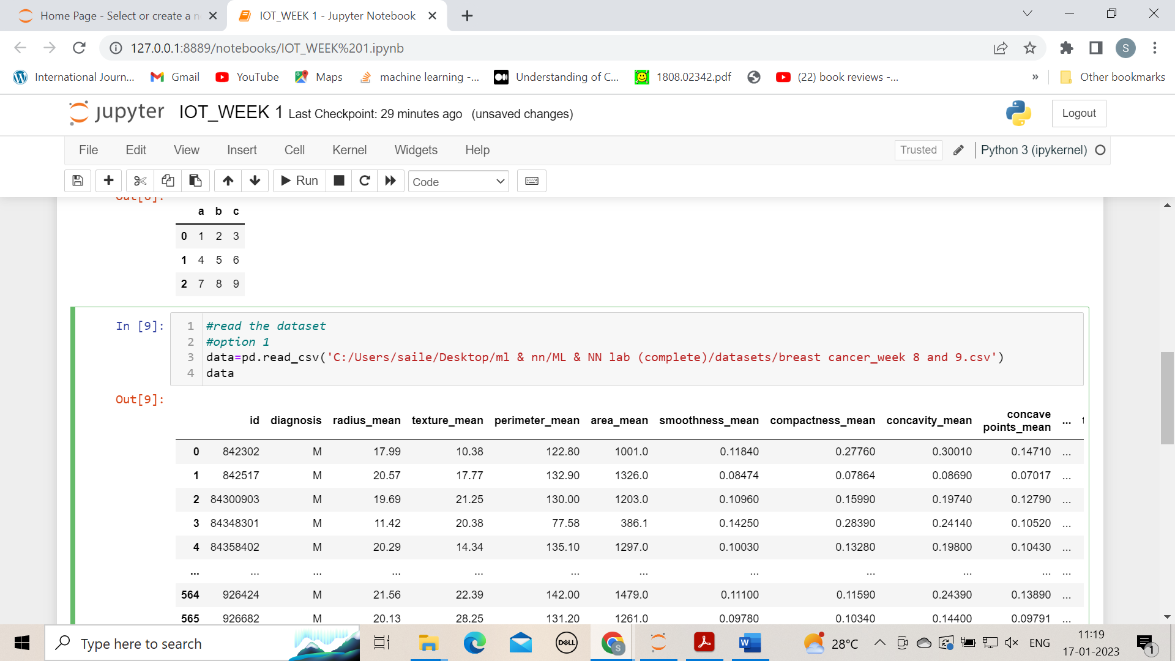

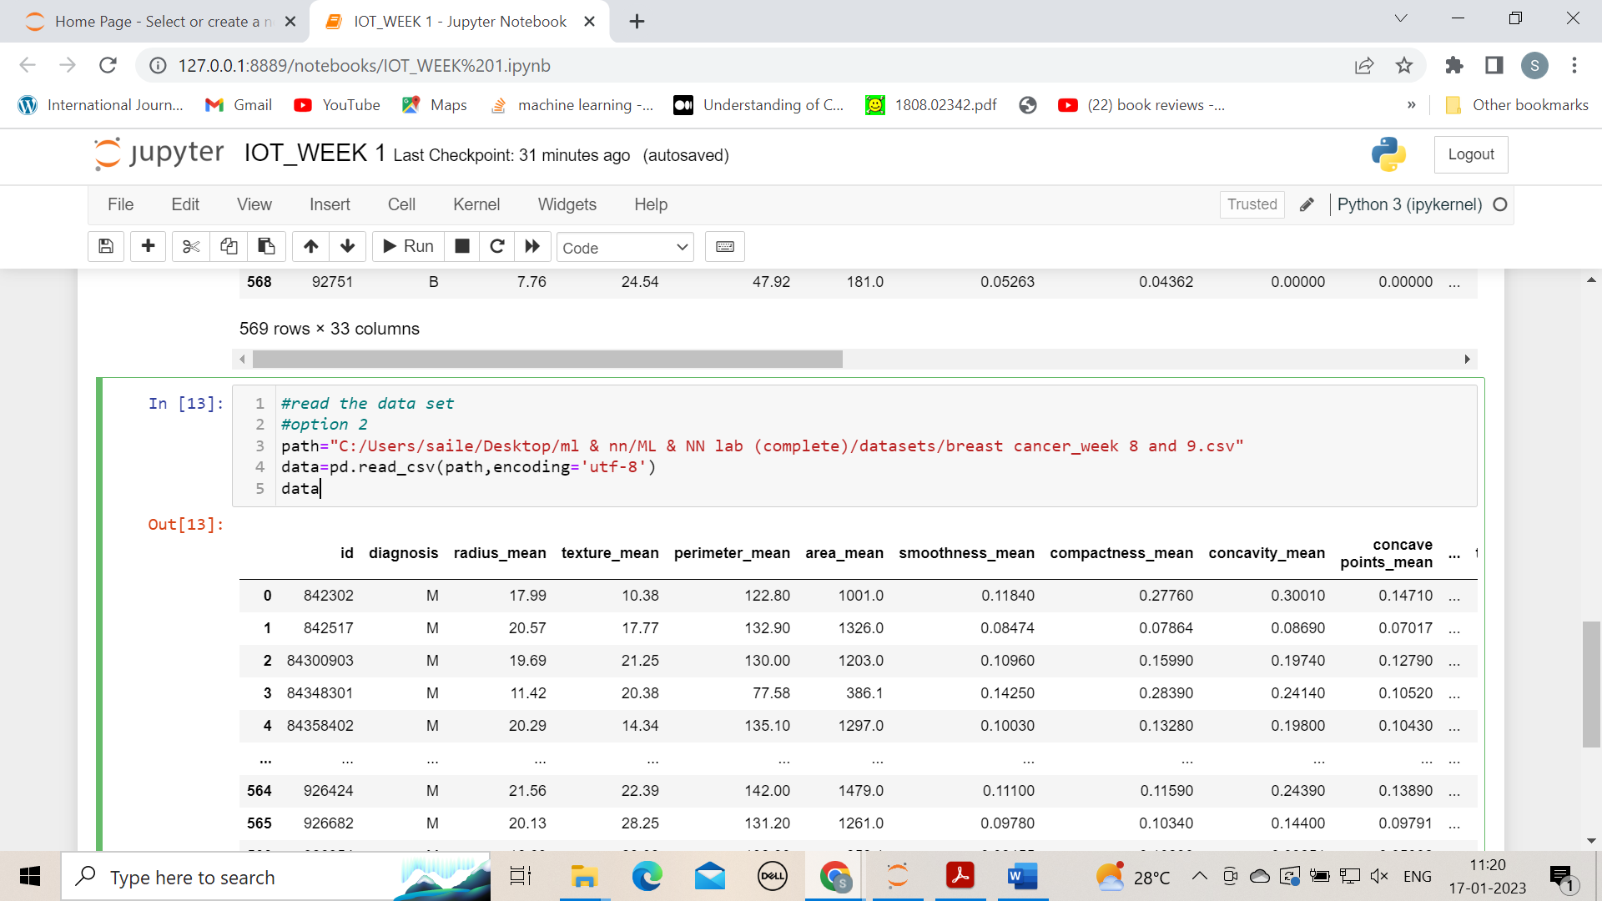

### **2. Dimensions of the data**

* The data set which we have taken have 569 rows and 33 columns
* We have two dimensions – i.e. a 2D data frame with height and width. If your data had only one column, ndim would return 1. Data sets with more than two dimensions in Pandas used to be called Panels, but these formats have been deprecated.
* The recommended approach for multi-dimensional (>2) data is to use the [Xarray](http://xarray.pydata.org/en/stable/) Python library.

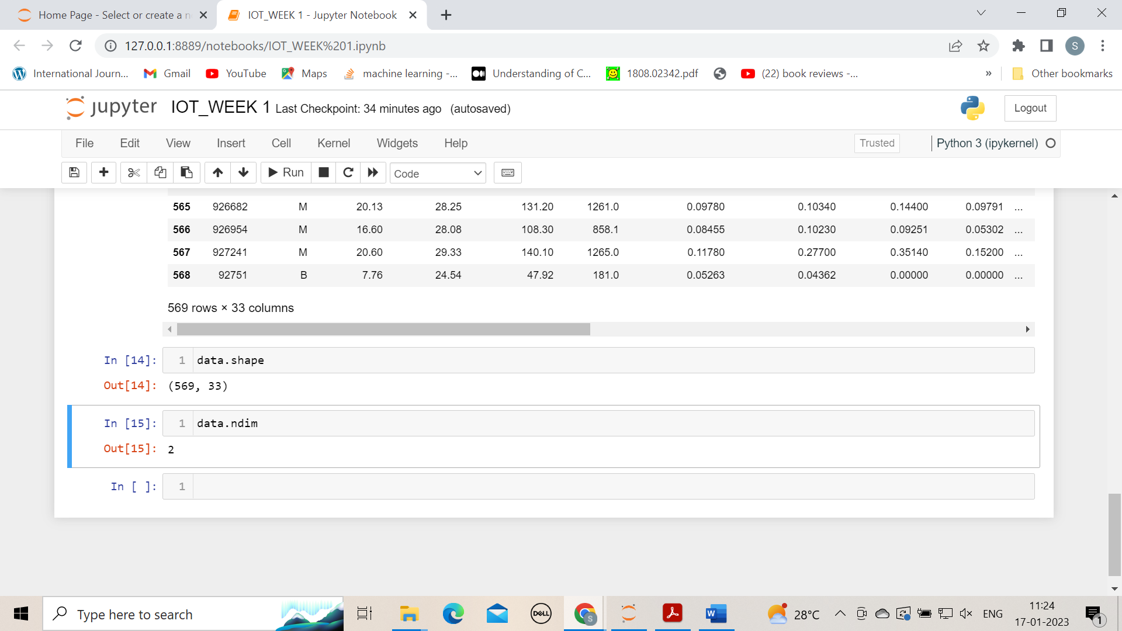

**3. Display data (top 5 rows and total data)**

### Preview Data Frames with head() and tail()

* The DataFrame. head() function in Pandas, by default, shows you the top 5 rows of data in the Data Frame.
* The opposite is DataFrame.tail(), which gives you the last 5 rows.
* Pass in a number and Pandas will print out the specified number of rows as shown in the example below.
* Head() and Tail() need to be core parts of your go-to Python Pandas functions for investigating your datasets.

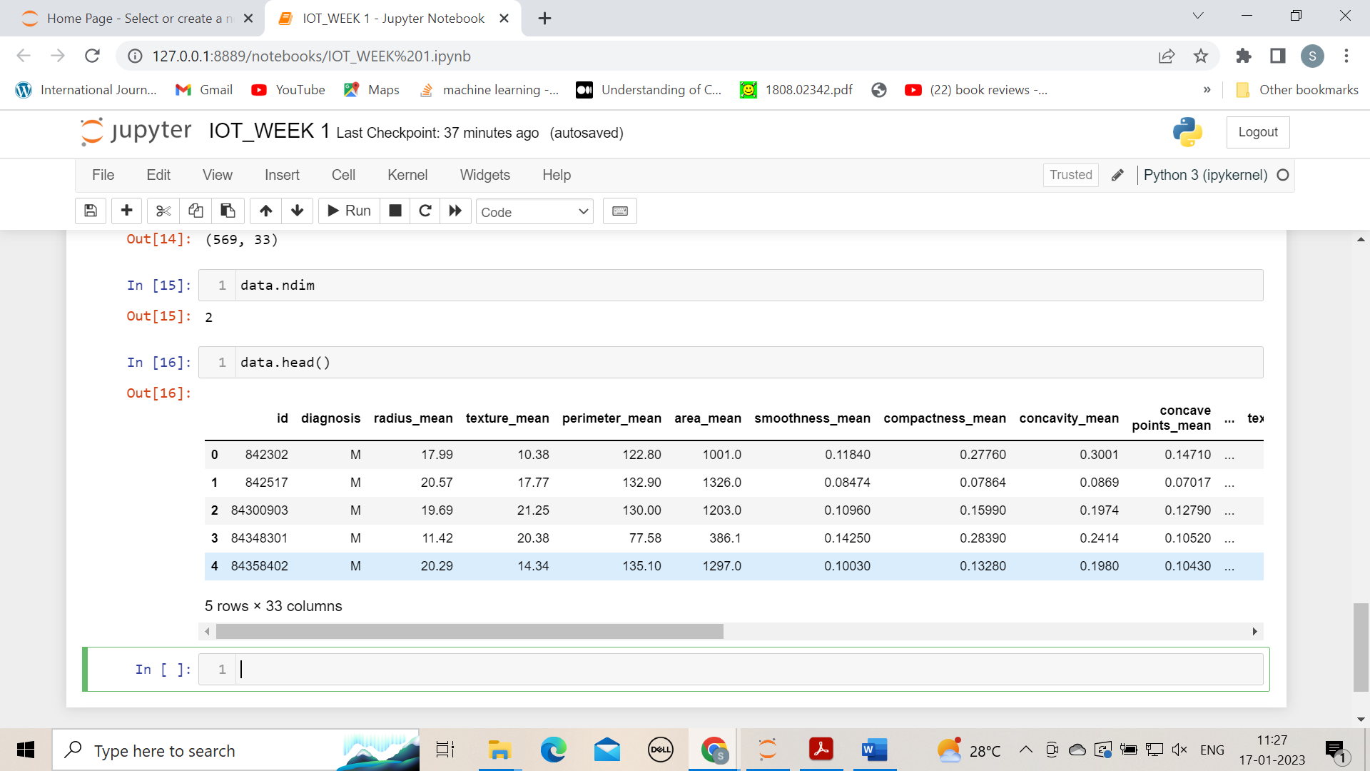

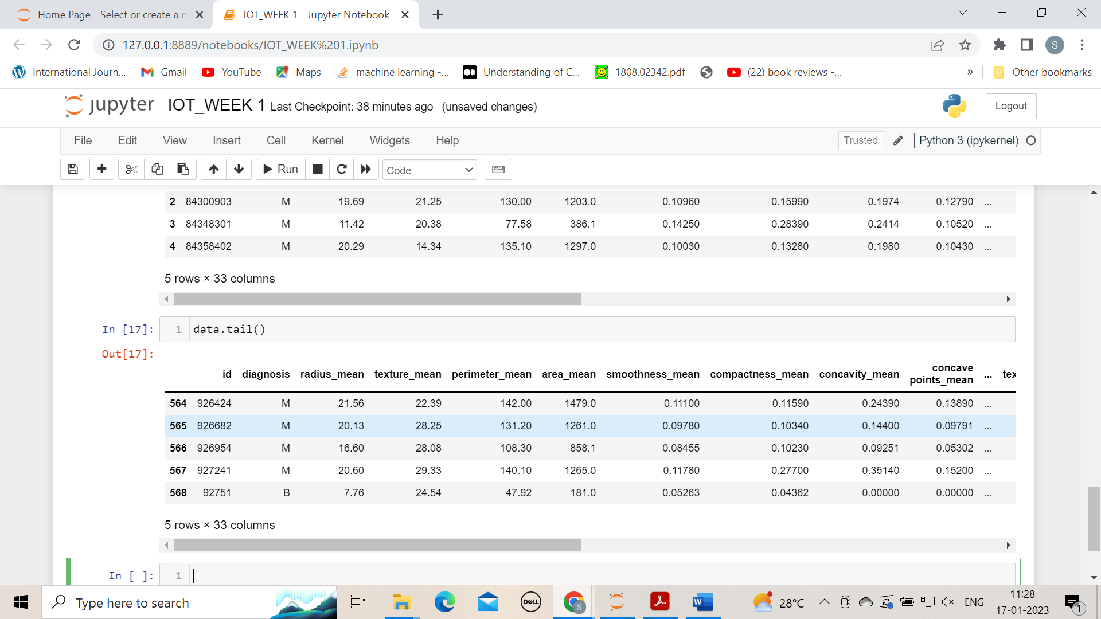

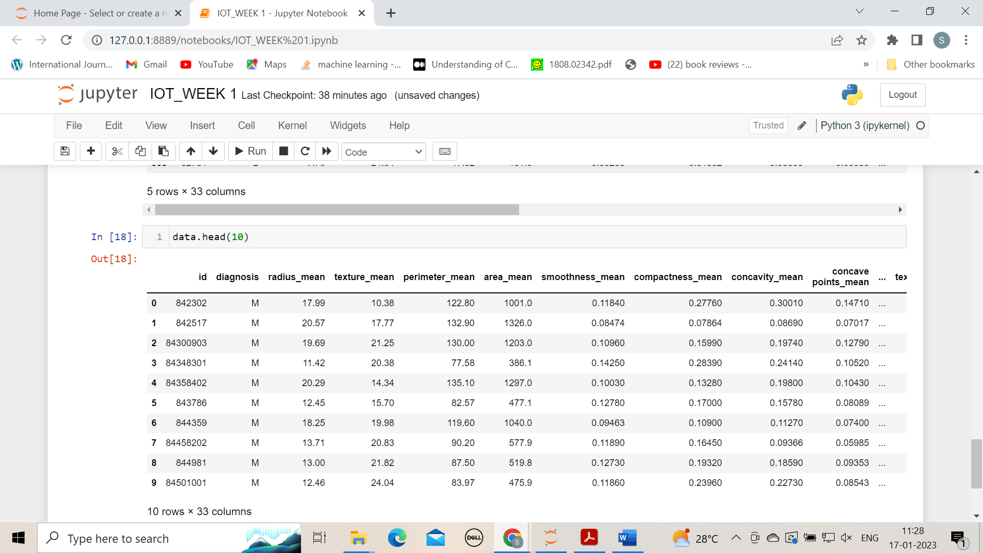

**4. List the column names of a data frame**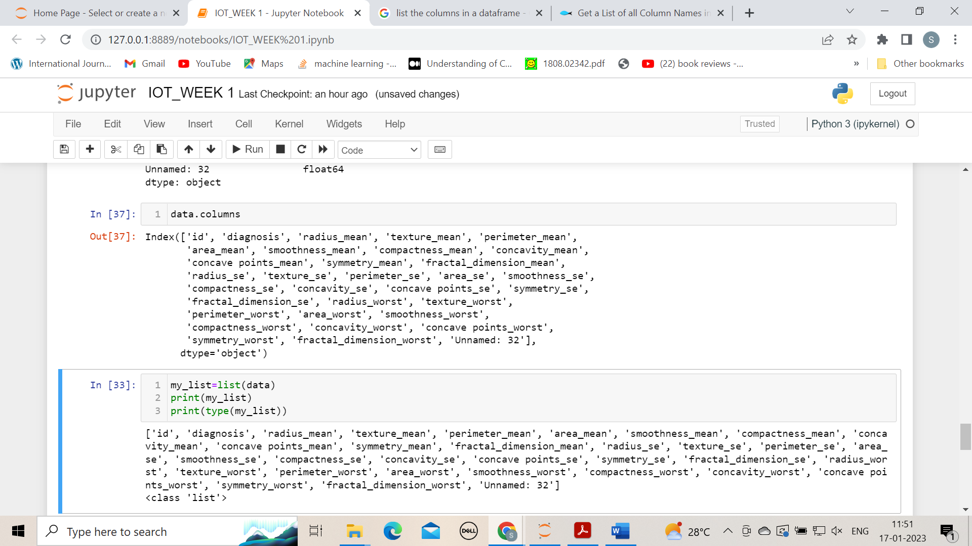

### **5. Change columns of a data frame**

Column renames are achieved easily in Pandas using the [DataFrame rename](https://pandas.pydata.org/pandas-docs/version/0.21/generated/pandas.DataFrame.rename.html" \t "_blank) function.

The rename function is easy to use, and quite flexible.

Rename columns in these two ways:

* Rename by mapping old names to new names using a dictionary, with form {“old\_column\_name”: “new\_column\_name”, …}
* Rename by providing a function to change the column names with. Functions are applied to every column name.

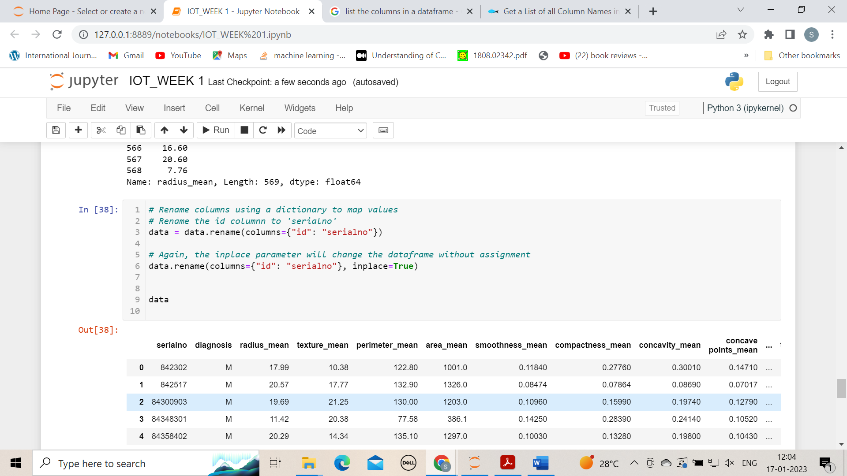

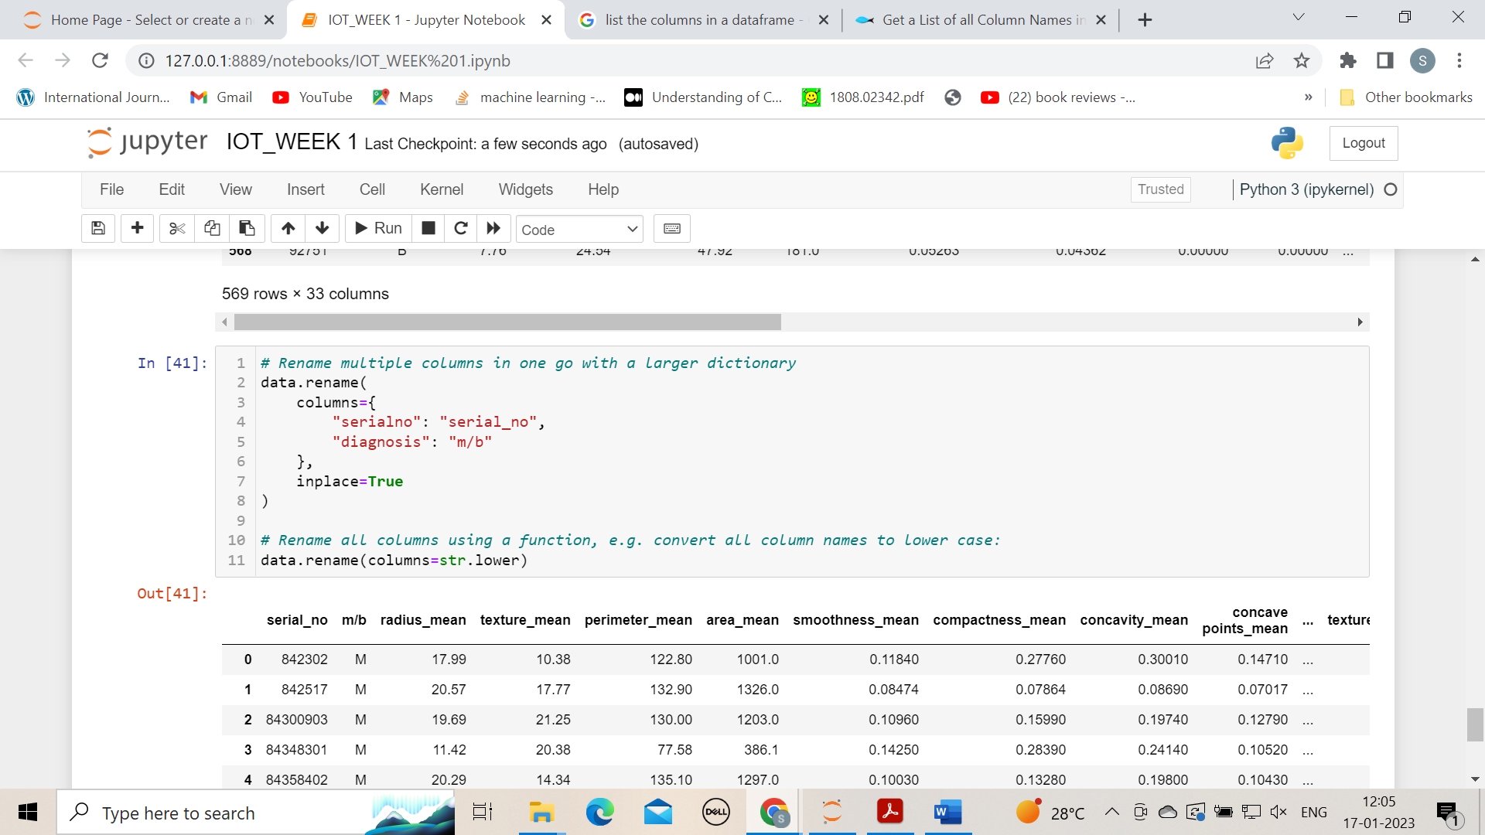

**6. Display specific single column or multiple columns of a data frame**

There are three main methods of selecting columns in pandas:

* using a dot notation, e.g.

data.column\_name

* using square braces and the name of the column as a string, e.g.

data**[**'column\_name'**]**

* or using numeric indexing and the iloc selector

data.iloc**[**:, **<**column\_number**>]**

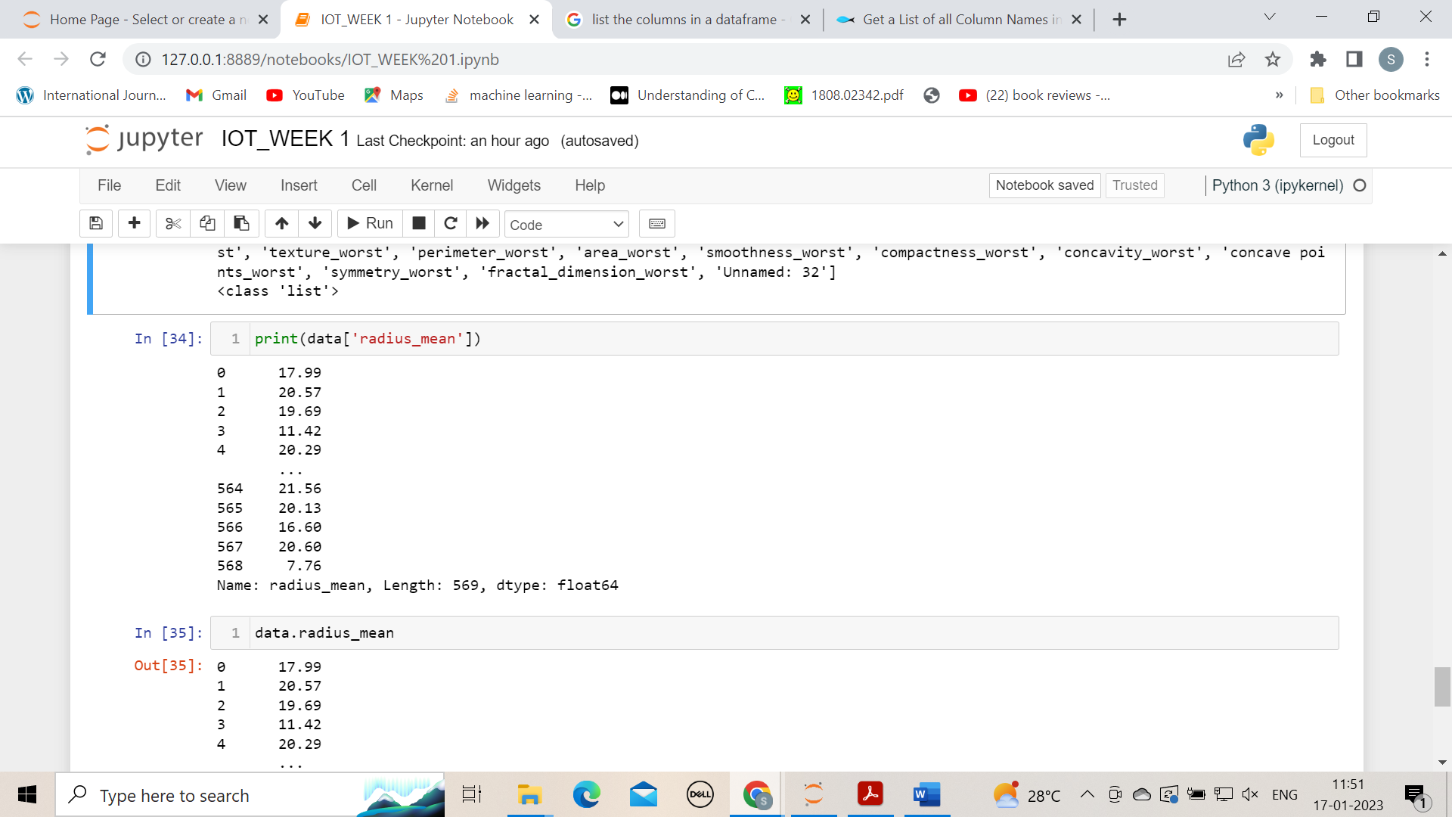

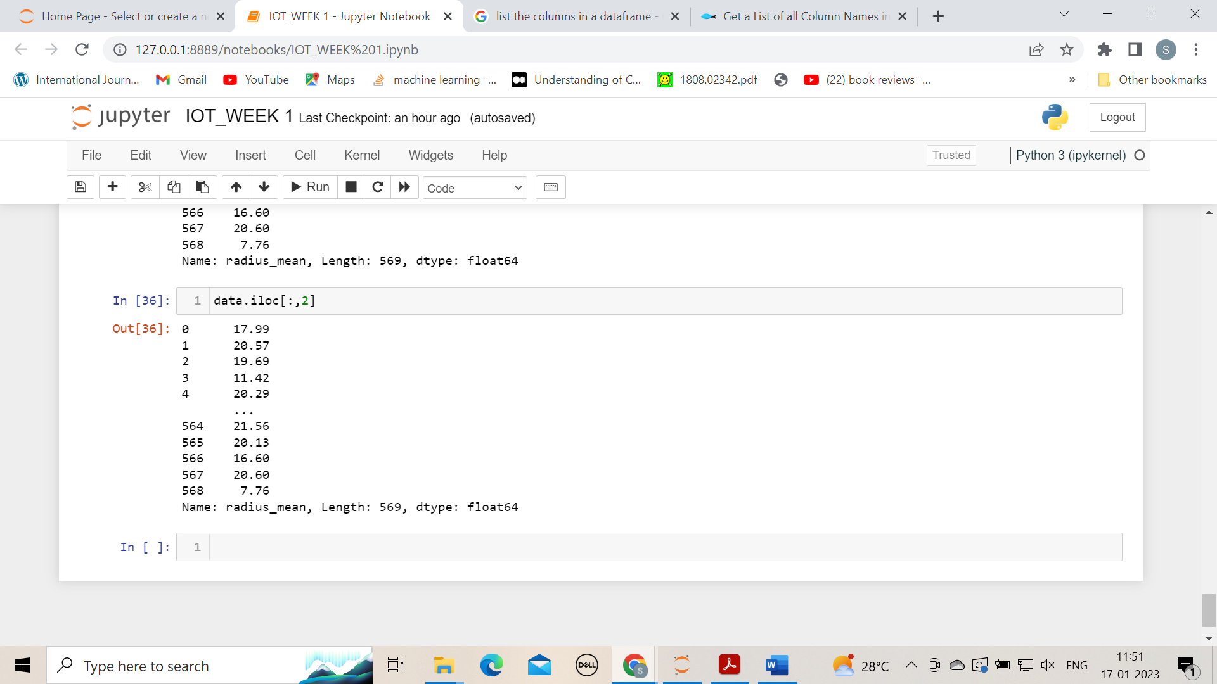

**7.Bind sets of rows of data frames**

Column bind and row bind in python pandas using concat() Function

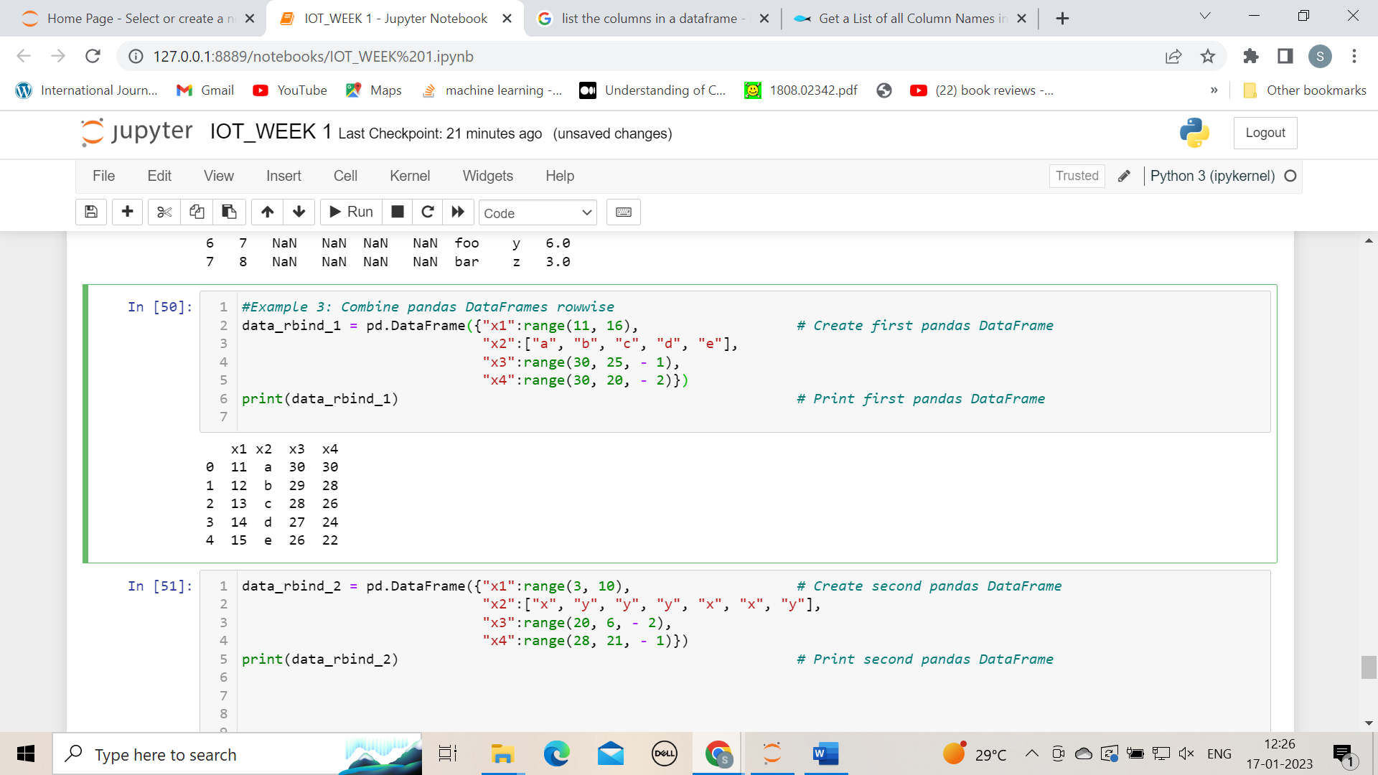

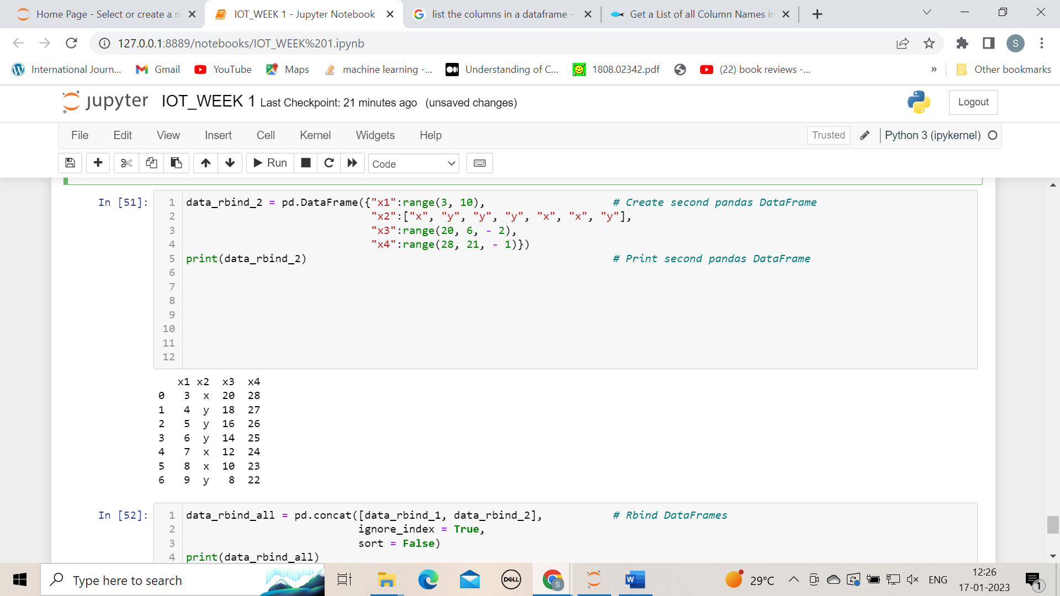

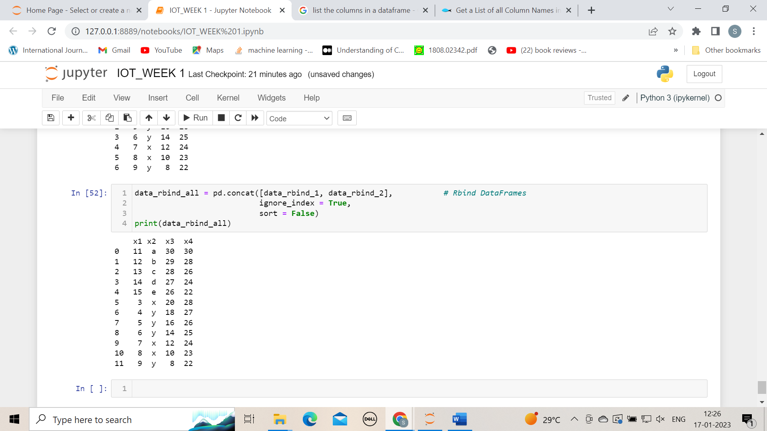

**8. Bind sets of columns of data frames**

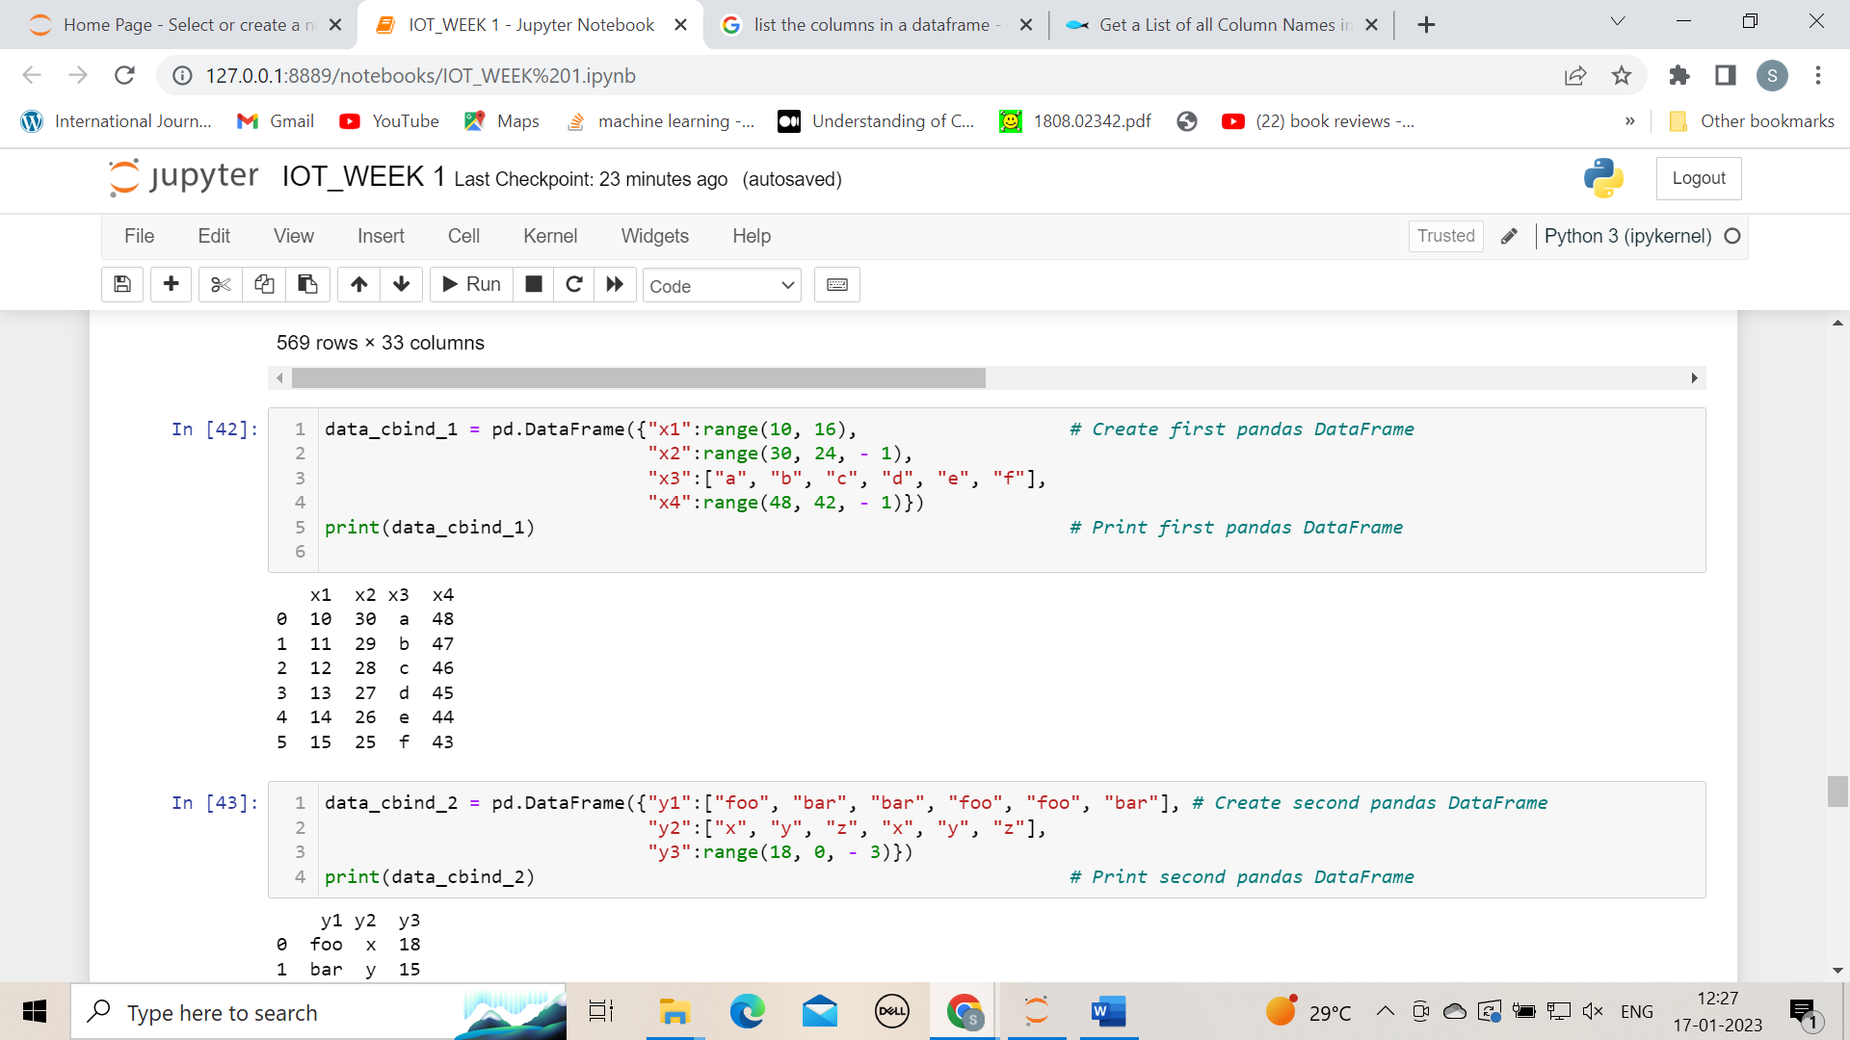

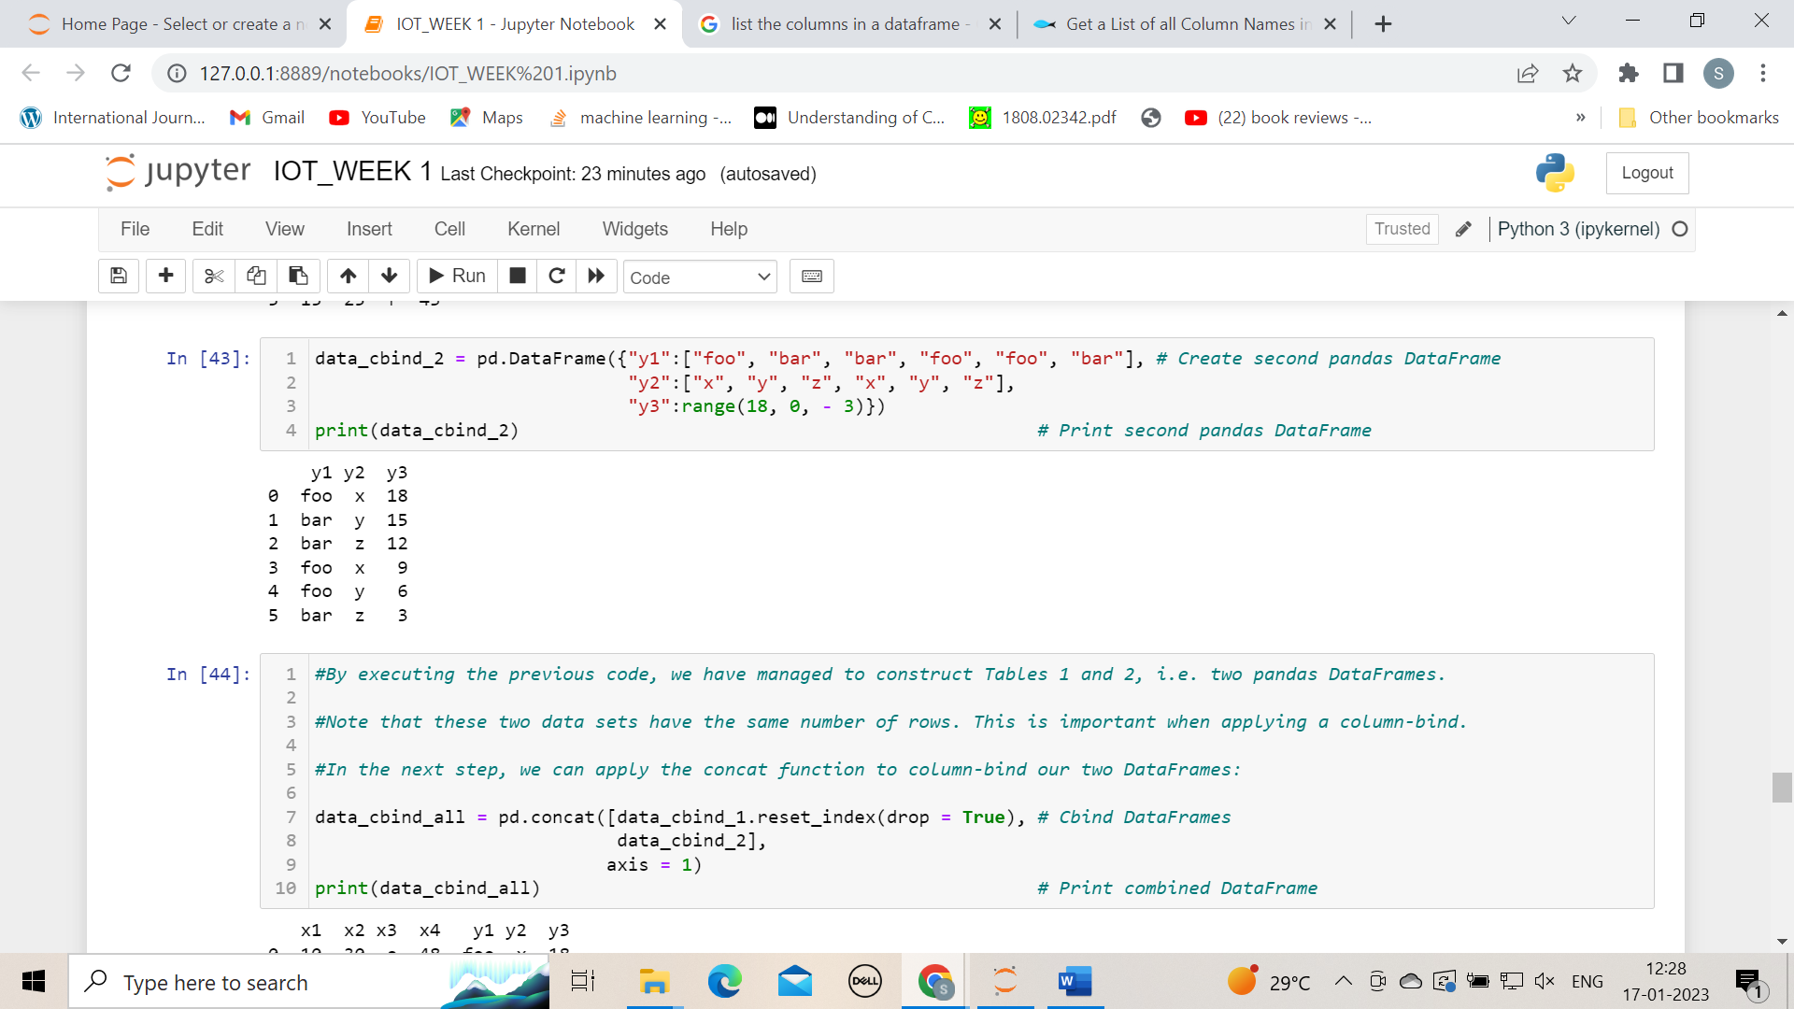

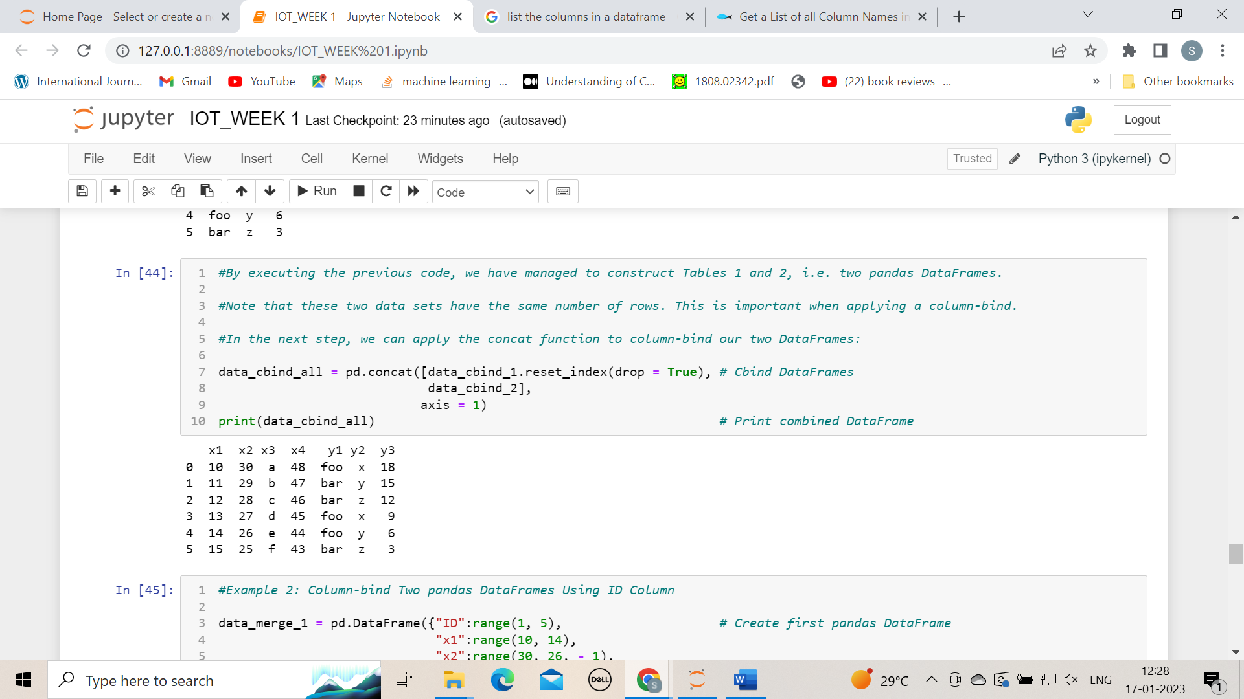

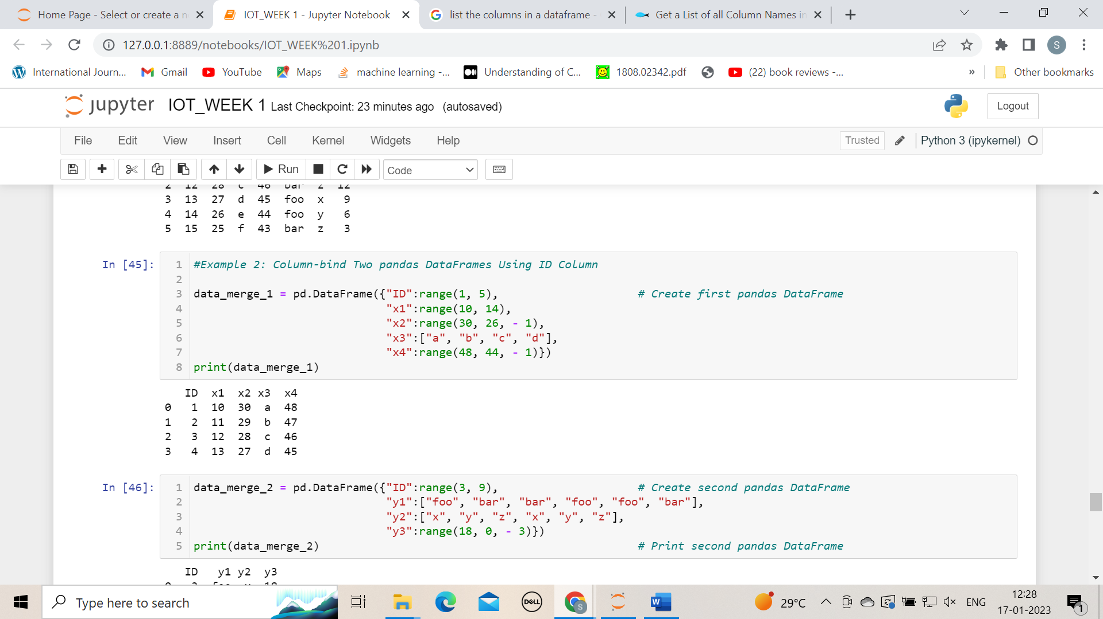

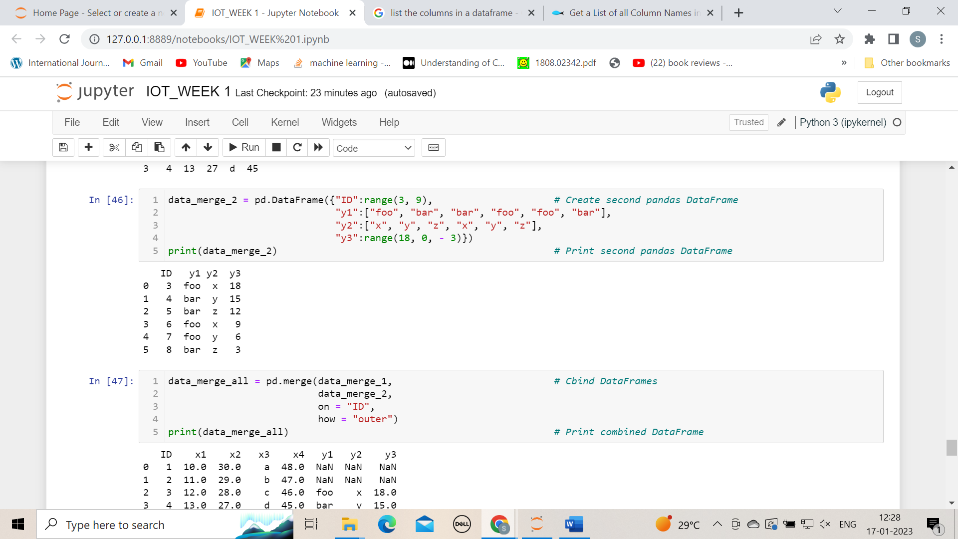

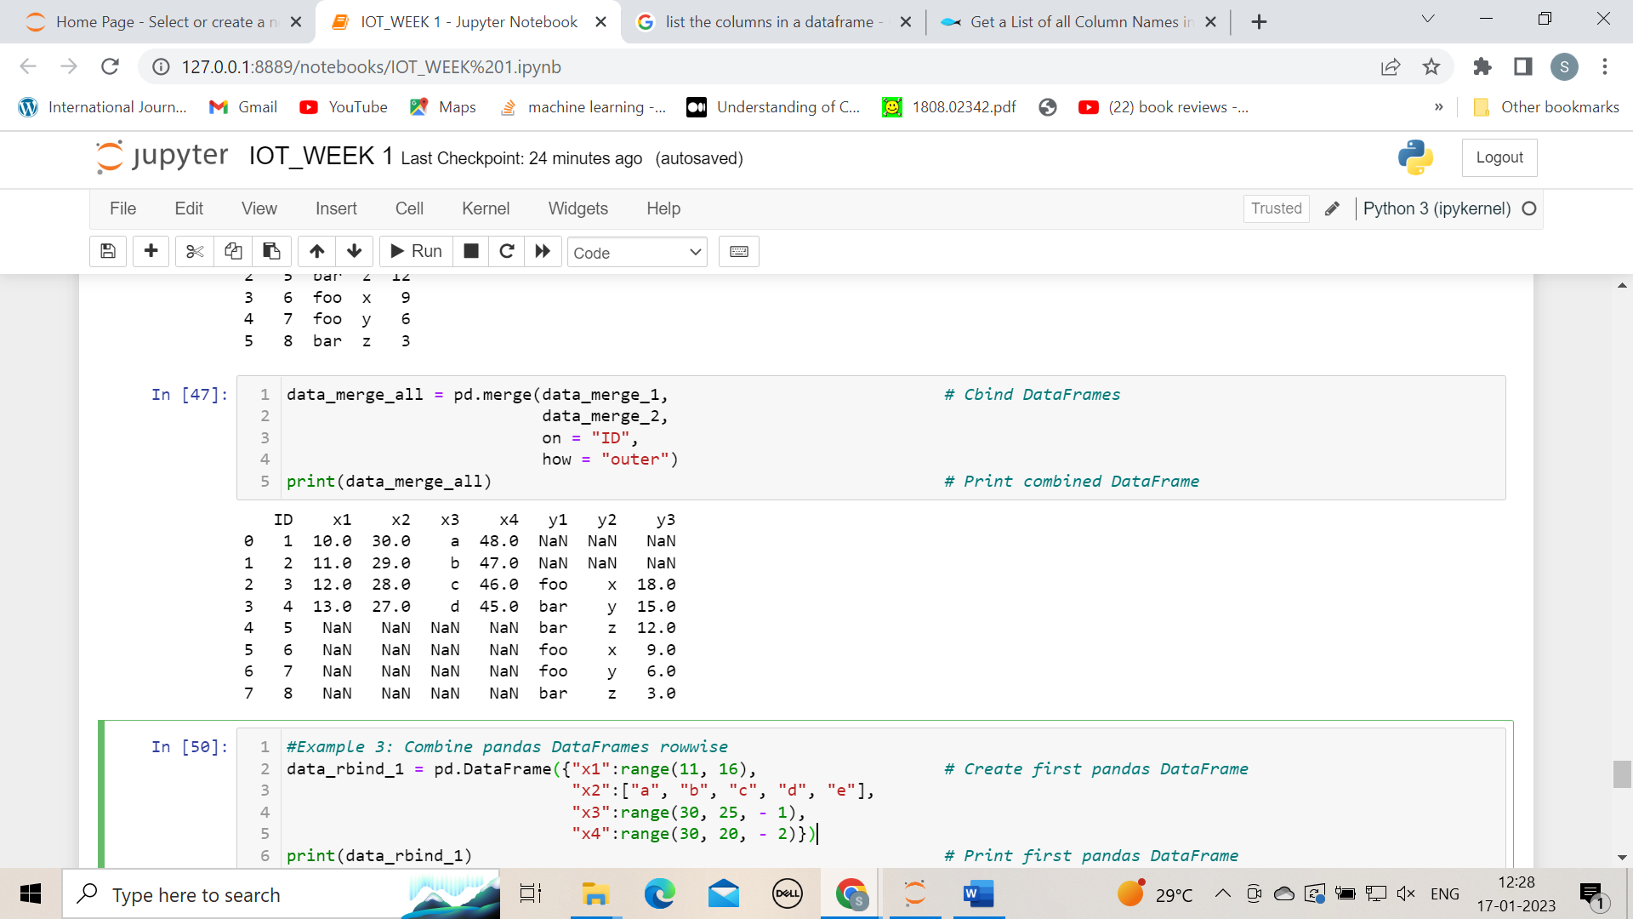

**9. Find missing values in the dataset**

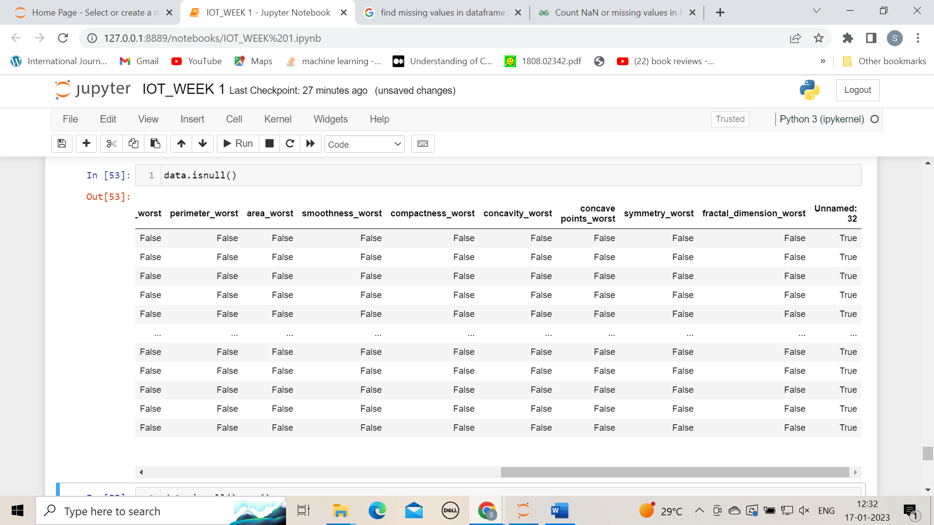

**Additional programs of week 1**

### **1.Manually entering data**

There’s multiple ways to create Data Frames of data in Python, and the simplest way is through typing the data into Python manually, which obviously only works for tiny datasets.

**#manually entering the data**

**#import the pandas library as create an alias name as pd**

import pandas as pd

**#Constructing Data Frame from a dictionary.**

>>> d = {'col1': [1, 2], 'col2': [3, 4]}

>>> df = pd.DataFrame(data=d)

>>> df

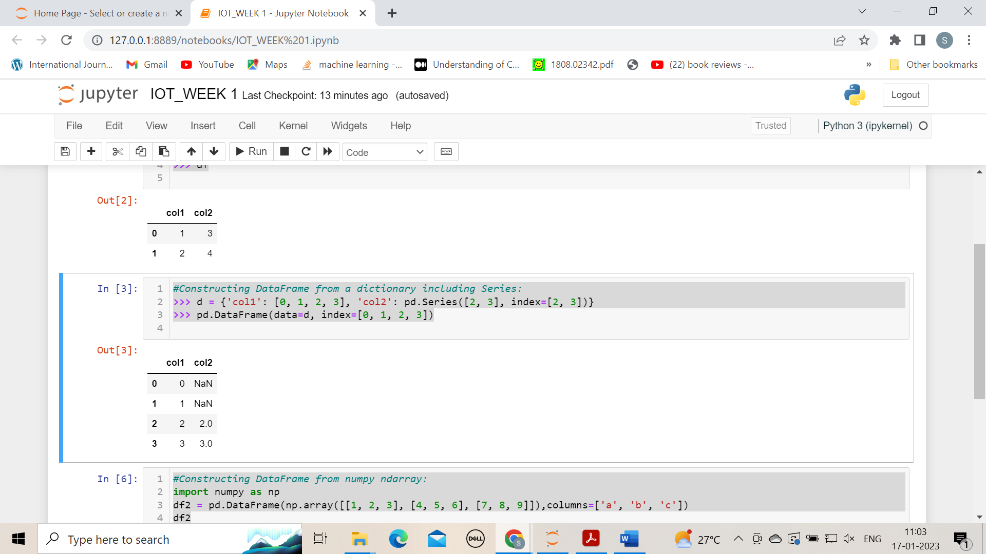

**#Constructing DataFrame from a dictionary including Series:**

>>> d = {'col1': [0, 1, 2, 3], 'col2': pd.Series([2, 3], index=[2, 3])}

>>> pd.DataFrame(data=d, index=[0, 1, 2, 3])

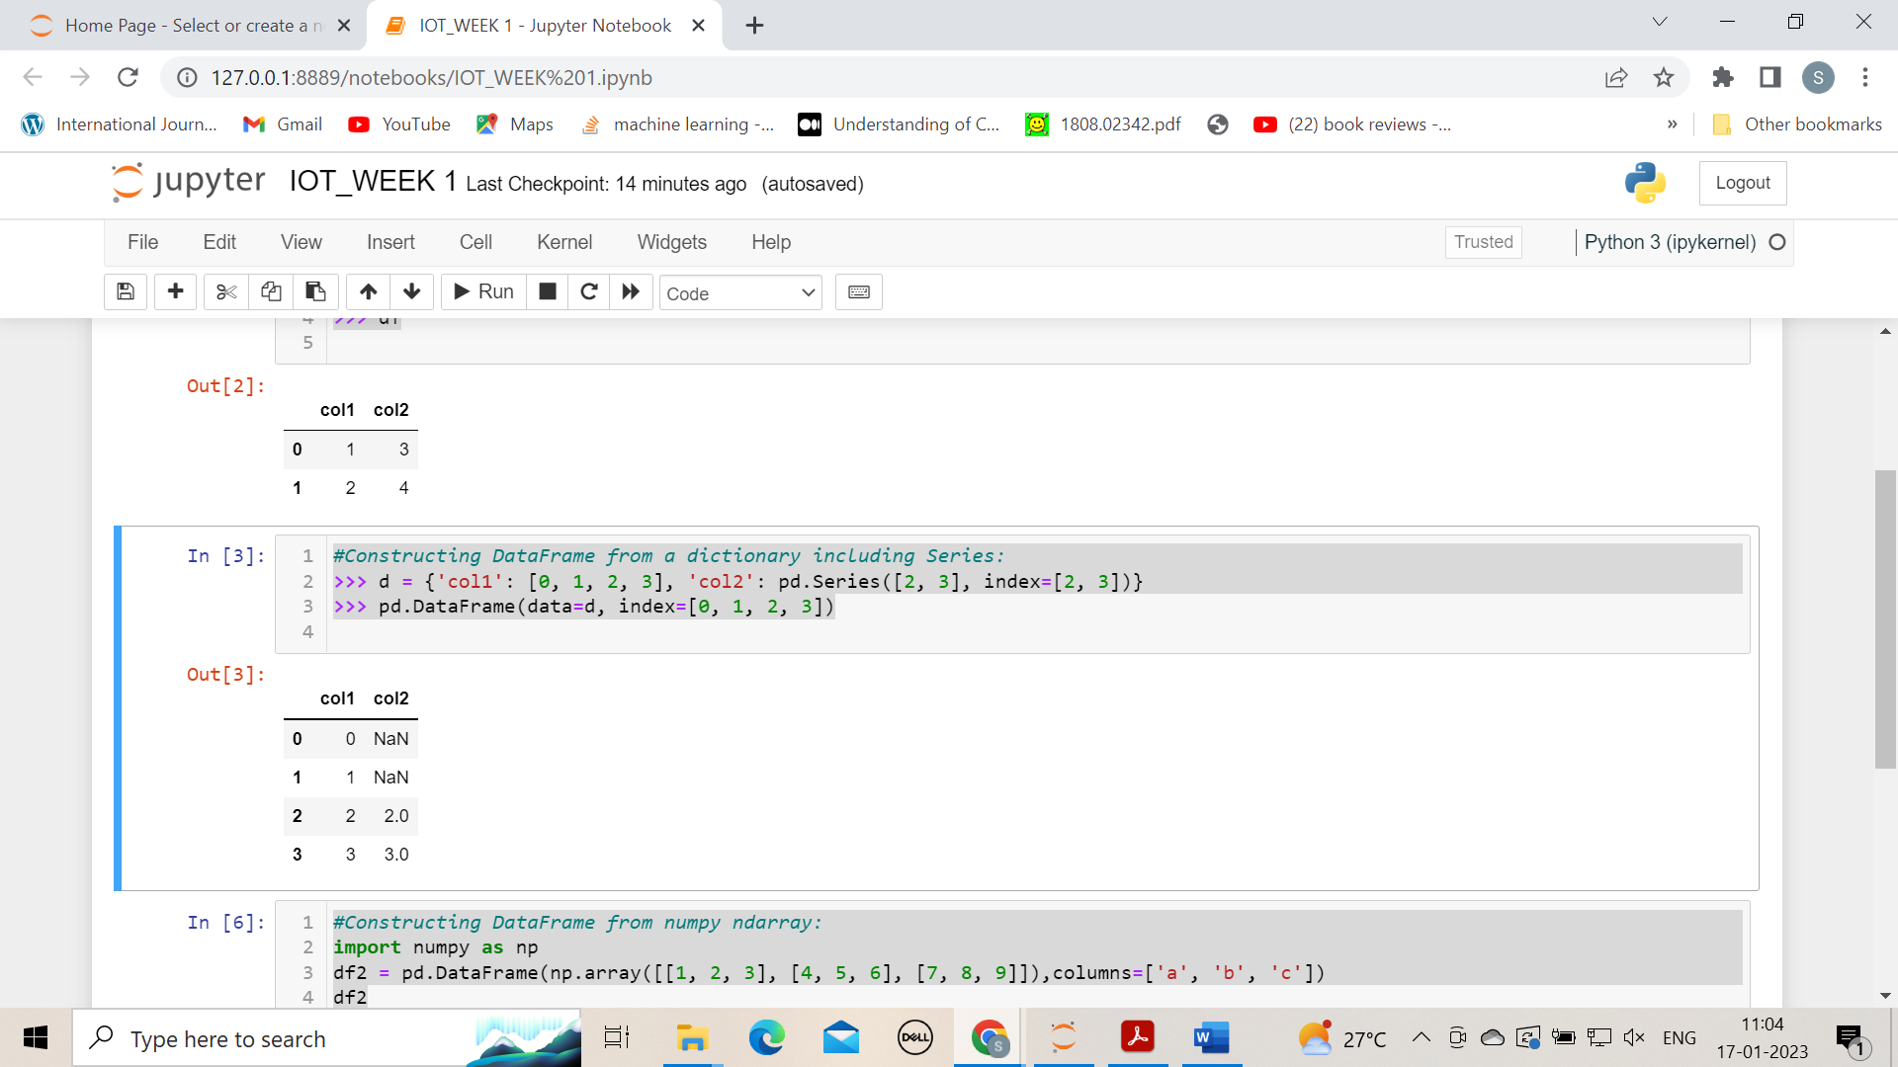

**#Constructing Data Frame from numpy ndarray:**

import numpy as np

df2 = pd.DataFrame(np.array([[1, 2, 3], [4, 5, 6], [7, 8, 9]]),columns=['a', 'b', 'c'])

df2

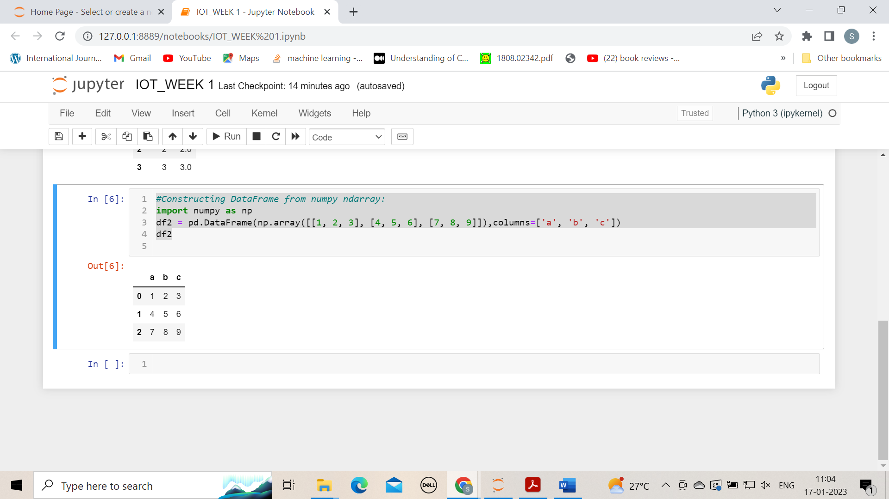

### **2. Data types (dtypes) of columns**

Many DataFrames have mixed data types, that is, some columns are numbers, some are strings, and some are dates etc. Internally, CSV files do not contain information on what data types are contained in each column; all of the data is just characters. Pandas infers the data types when loading the data, e.g. if a column contains only numbers, pandas will set that column’s data type to numeric: integer or float.

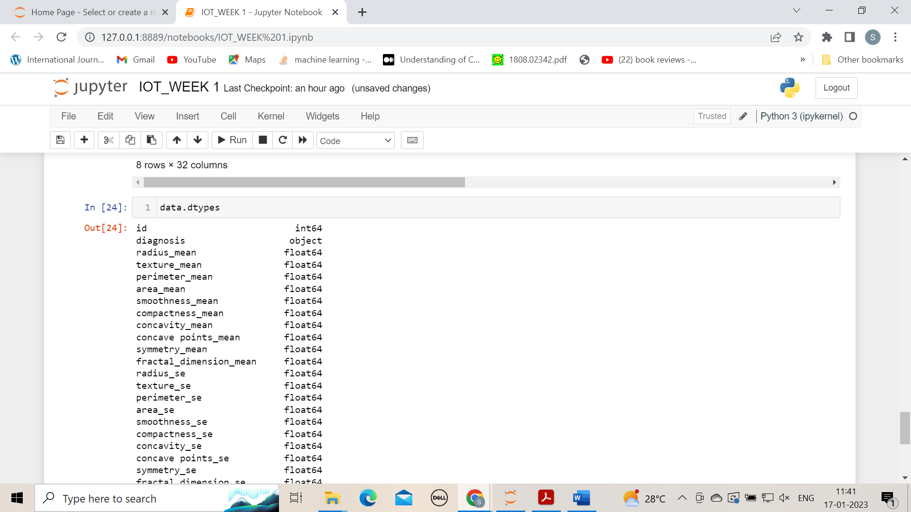

**3.Print specific columns from the dataset**

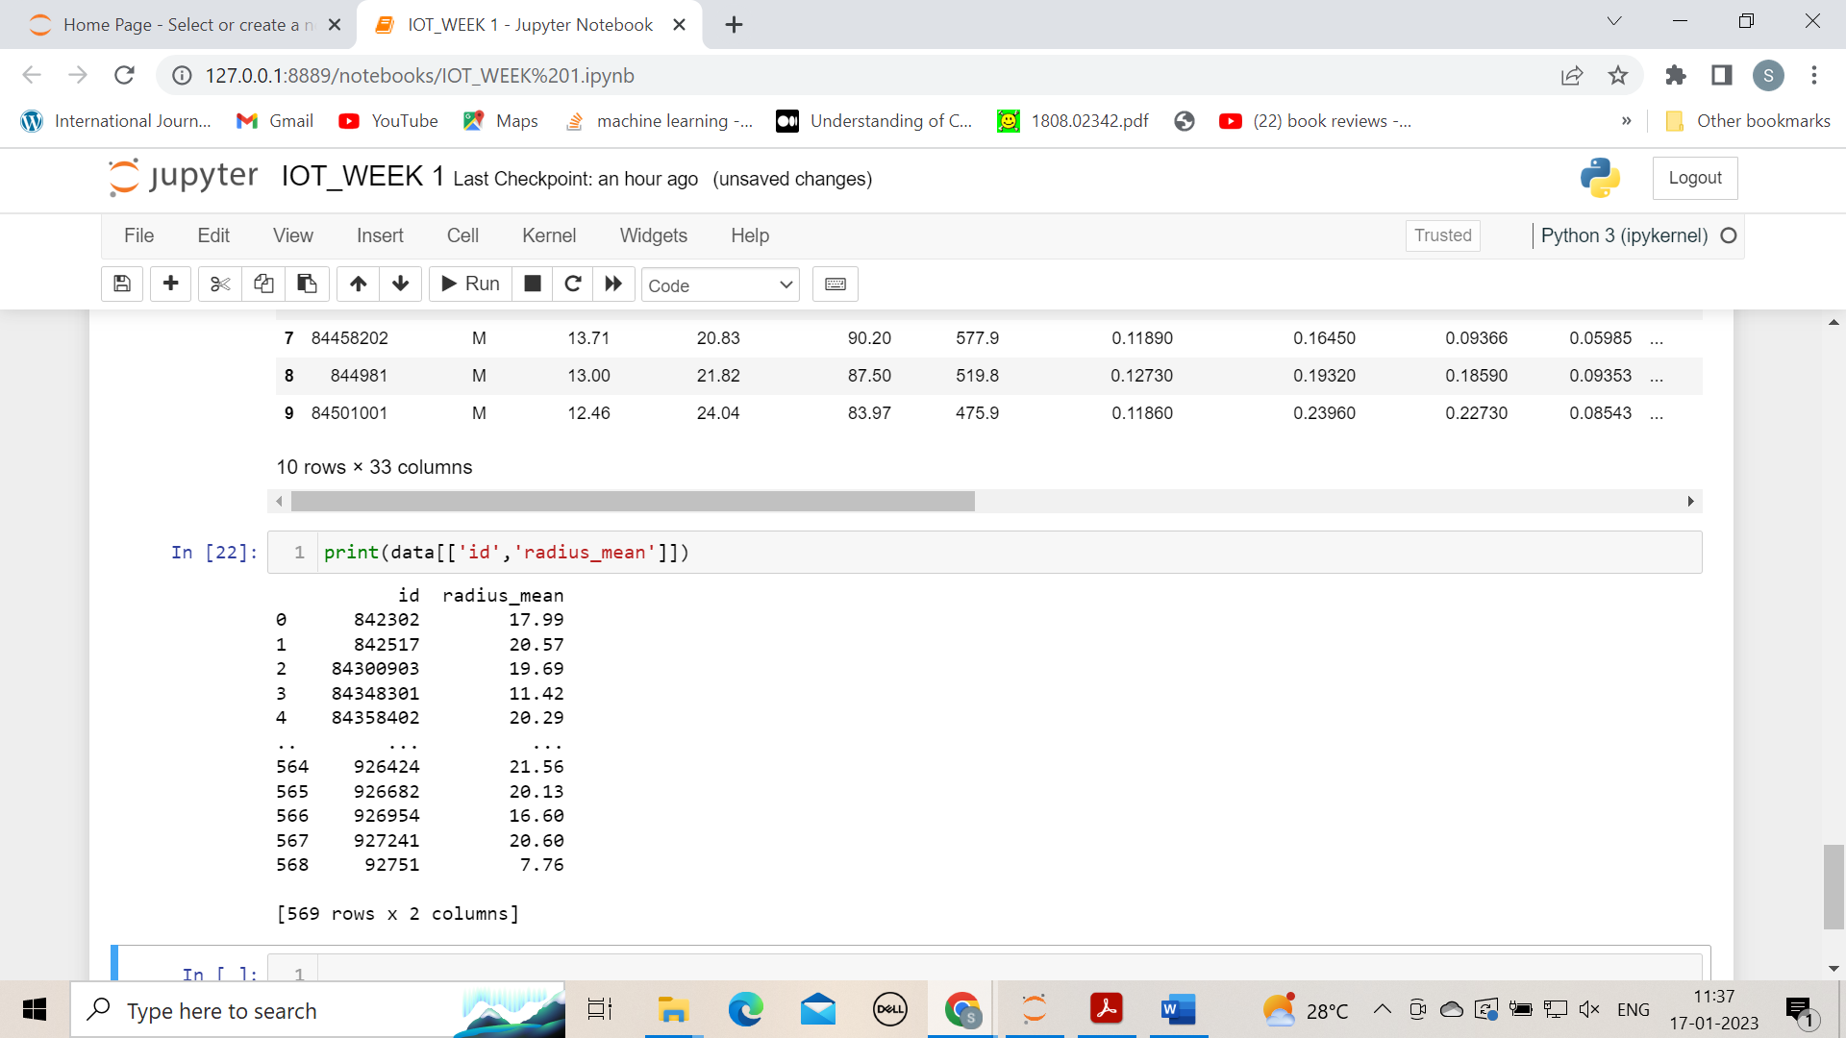

### **4. Describing data with .describe()**

Data. describe()

### **5. Deleting rows and columns (drop)**

To delete rows and columns from DataFrames, Pandas uses the “[drop](https://pandas.pydata.org/pandas-docs/version/0.21/generated/pandas.DataFrame.drop.html)” function.

To delete a column, or multiple columns, use the name of the column(s), and specify the “axis” as 1. Alternatively, as in the example below, the ‘columns’ parameter has been added in Pandas which cuts out the need for ‘axis’. The drop function returns a new DataFrame, with the columns removed. To actually edit the original DataFrame, the “inplace” parameter can be set to True, and there is no returned value.

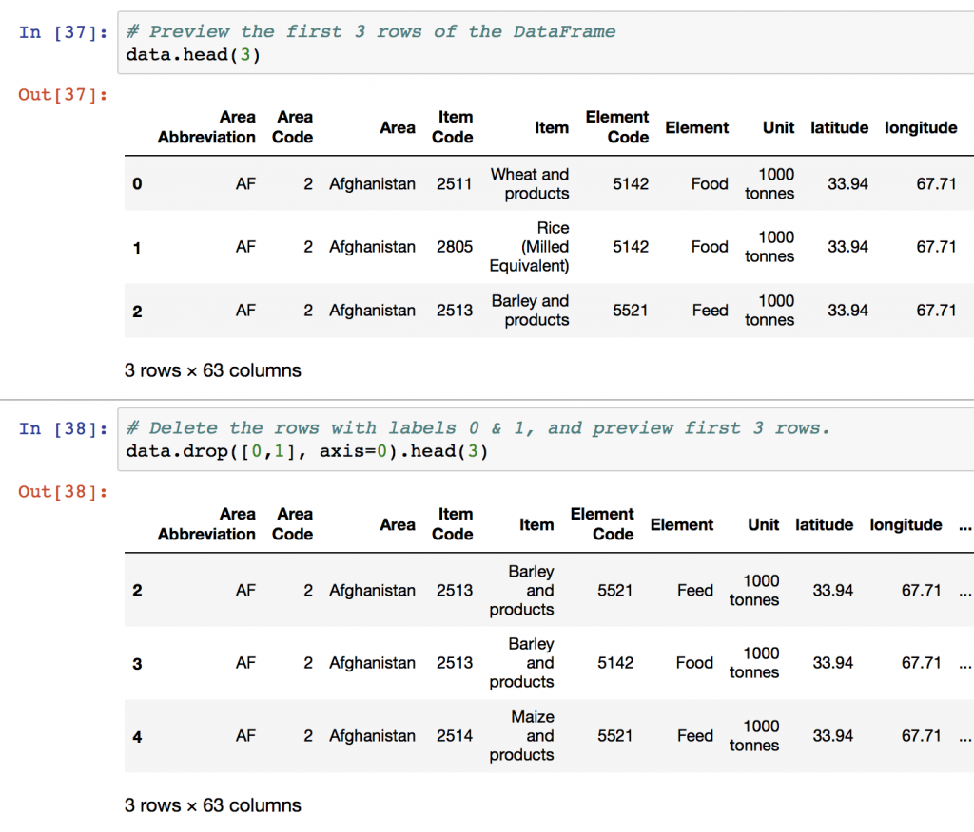

## 6. Exporting and Saving Pandas DataFrames

After manipulation or calculations, saving your data back to CSV is the next step. Data output in Pandas is as simple as loading data.

Two two functions you’ll need to know are [to\_csv](https://pandas.pydata.org/pandas-docs/stable/generated/pandas.DataFrame.to_csv.html" \t "_blank) to write a DataFrame to a CSV file, and [to\_excel](https://pandas.pydata.org/pandas-docs/stable/generated/pandas.DataFrame.to_excel.html" \t "_blank) to write DataFrame information to a Microsoft Excel file.

